SHORT TEST 3 CORRECTION

Before we dive in: what is a linear regression, really?
Let's back up for a second and be really clear about what we're doing when we run a linear regression.
A linear regression is not an inherent property of the data we analyze : it’s a decision we make as data analyst ! It’s the decision to model the relationship between two variables as a linear relationship : not exponential, not logarithmic, not anything else. Linear. We're saying: I'm going to assume that my y depends on my x in the simplest possible way, through the equation you already know from middle school:
y = ax + b
In words: the value of my y (say, my sales) is given by the value of my x (say, my price) multiplied by a coefficient a; plus another coefficient b.
You may remember that the visual representation of this kind of relationship is… a line. And both features of that line are given directly by the math:
- a is the slope. Even visually: how slopy the line is. Mathematically, the slope tells you what happens to y when you increase x by one unit. If a is positive, y goes up when x goes up (i.e. the line is upward); if a is negative, y goes down when x goes up (i.e. the line is downward).
- b is the intercept (« l'ordonnée à l'origine »): the exact spot where the line crosses the y-axis — in other words, the value of y at the moment when x = 0.

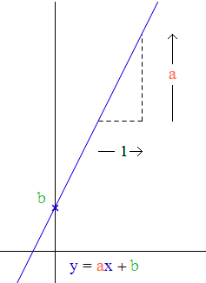

That is the entire mathematical content of a linear regression. Everything else standard errors, p-values, R², is just extra information telling you how good that line is at describing what's actually going on in the data and beyond our sample. But the line itself is the whole point. Keep that image in your head as you read the answers below.
In our regressions, by convention we call a the slope coefficient (β₁) and b the intercept (β₀), so the equation you'll see written in the questions is:
y = β₀ + β₁ × x
Which is the exact same thing as y = ax + b, just with fancier symbols and the two terms swapped around.

Question 1
Here, we're using education (in years) to predict monthly income (in thousands of dirhams). The line the regression has fitted is:
Income = 1.2 + 0.45 × (Years of Education)
Let's read each piece.
The intercept (β₀ = 1.2) is where the line crosses the y-axis. It tells us the predicted monthly income for someone with zero years of education: about 1,200 dirhams per month. Careful though : nobody in a real sample has exactly zero years of education, so this is really the mathematical anchor of the line, not a realistic prediction we should take too seriously in itself. This shows you the limits of « modeling » data : modelling is nothing but applying a mathematical formula to the data. This can be useful, and sometimes misleading. It’s the analyst’s job to interpret it properly ! In this specific case, we can say that the value of the intercept does not tell us anything meaningful.
The slope (β₁ = 0.45) is the interesting part. It tells us that each additional year of education is associated with a predicted increase of 0.45 thousand dirhams (i.e. 450 dirhams) in monthly income. The slope is positive: more education, more income. That matches the intuition most of us would have.
NB : by definition, a linear regression gives you… a linear relationship. If there are non-linear patterns in your data (e.g., maybe moving from L1 to L2 increases income less than moving from L2 to L3), this will not be captured by the model ! Again, it is not the relationship that is linear, it is you who decides to model the relationship as a linear relationship.
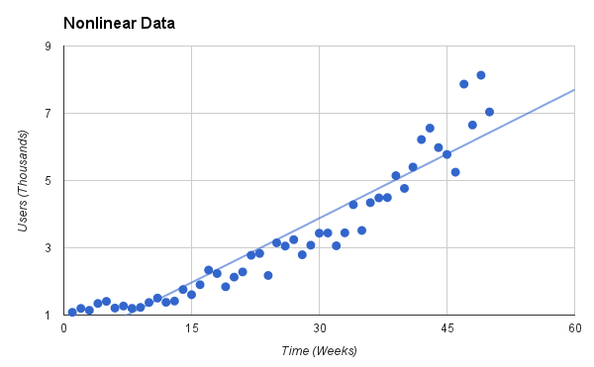

Example of a linear model fitted on smth that looks more like an exponential patterns. The linear regression is not so bad : it does fit your data well, but you see that it won’t capture the exponential dynamics !
The standard errors tell us how precisely we've estimated each of those numbers. Remember: our regression line was fitted on a sample of 250 people. If we had drawn a different sample of 250, we would have gotten slightly different numbers. The SE tells us roughly how much our estimate would jump around from sample to sample. Here, the SE of the slope is 0.22, which is pretty big compared to the slope itself (0.45). A rough 95% confidence interval for the slope is 0.45 ± 1.96 × 0.22, so roughly [0.02, 0.88]. In other words: the true slope in the population could plausibly be almost zero, or almost twice what we found. That's a wide range, and it means we've estimated the slope with limited precision.
The p-values ask a specific question: if the true value of this coefficient in the population were exactly zero (e.g. : imagine that in real life, education and income have absolutely 0 relationship), how surprising would it be to observe the value we got in our sample, just by sampling luck? A small p-value means "very surprising ! So surprising in fact, that probably the true value is not zero."
* For the intercept (p = 0.003). The p-value is asking a specific question: if the true intercept in the population were actually zero, what is the probability that we would end up with an estimate as far from zero as ours (1.2) — or even further — just because of the random luck of which 250 people happened to land in our sample? Here, that probability is 0.003, or 0.3%. That's tiny. Less than 3 chances out of 1000. So we conclude that it is very unlikely the true intercept is zero, and we reject the null hypothesis.
* For the slope (p = 0.043). Same logic: if the true slope in the population were actually zero — meaning education has no effect on income at all — the probability of getting an estimate as far from zero as ours (0.45) by pure sampling luck would be 4.3%. That's below the conventional 0.05 threshold, so we reject the null here too — but we're barely below the cutoff. Combined with the wide confidence interval we saw a moment ago, this tells us that the effect of education on income is real, but the evidence is not overwhelming.
NB : the 5 % cutoff is a widely used standard, but keep in mind that it’s arbitrary. There’s no valid mathematical reason to select 5 % as a cutoff instead of 10 % or 1 % or lower.
R² = 0.08. This tells us how much of the variation in income the model manages to explain. Here, 8%. Which means 92% of the variation in income is not explained by education. That's not a failure of the model : income depends on many things (job, sector, experience, family, region, gender, luck…) and education is only one of them. It's just important not to walk away from this thinking education is the main driver of income differences. It's not. It's one small piece.
Reading it all together: we have a real but modest positive association between education and income, imprecisely estimated, that explains only a small share of what makes people rich or poor.

Question 2
One property of a model (any model), is that it can be used to predict new values. It’s actually one of the main reasons we use models at all ! The added value of fitting a mathematical formula to data is our ability to make predictions based on new values. In our case, a linear model tells us for any value of X, what value of Y it predicts.
Here we're using price to predict weekly sales. The regression line the model has fitted is:
Weekly Sales = 85 − 1.5 × (Price)
The question is a direct application: if the price is 20 (thousand dirhams), what does the line predict for weekly sales? We just plug the number in:
Weekly Sales = 85 − 1.5 × 20 = 85 − 30 = 55
So the model predicts weekly sales of 55 thousand dirhams. It doesn’t mean that this is the truth. The difference between a predicted value and the actual truth is what is called the residual ; and we almost always have a residual. It just tells us that, according to the model, this is the prediction we make.

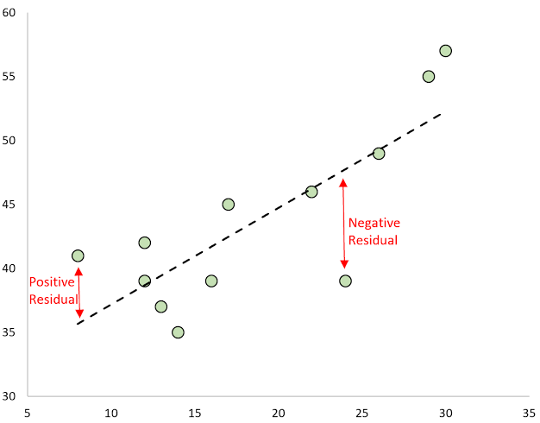

Question 3
The equation the model has fitted is:
Sleep Quality = 8.2 − 0.65 × (Screen Time)
The question is: what would this look like if I drew it?
The picture is a scatterplot with a fitted line on top.
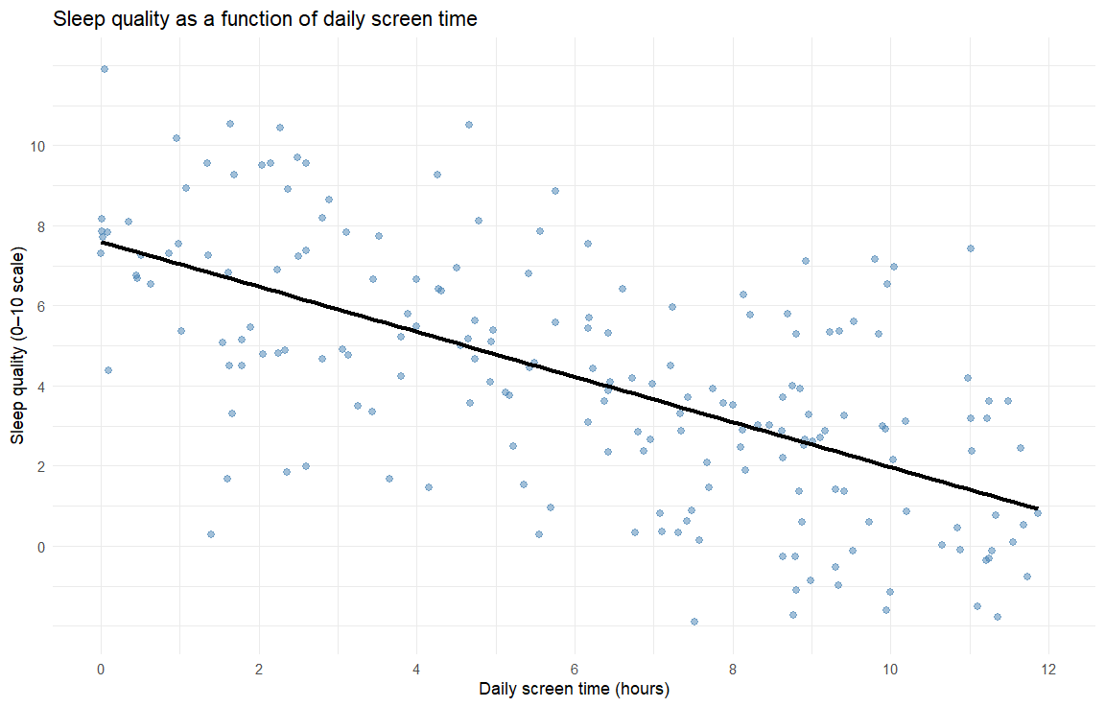
On the x-axis, we'd put the predictor: daily screen time, in hours, probably running from 0 to something like 12. On the y-axis, we'd put the outcome: self-reported sleep quality, on a 0–10 scale. Each of the 200 students in the sample would appear as one dot, positioned by their own screen time and their own sleep quality.
But the response I expected was a description of how the model would be represented !
First, because the model is a linear model, its visual representation will be a line.
Second, since the intercept is 8.2, the line starts high on the y-axis: at x = 0, the line sits at y = 8.2.
Third, the slope is negative (−0.65), so the line goes downward as we move to the right — for every extra hour of screen time, the line drops by 0.65 sleep-quality points.
This would have been the correct response. But we could have added some elements. For instance, how tightly do the dots fit the line? That's what R² tells us. Here R² = 0.28, meaning the model explains about 28% of the variance in sleep quality. That's not a lot, but it's not nothing either. So the dots would form a visible downward trend around the line, but with real scatter around it — two students with the same screen time could easily report quite different sleep quality, because screen time alone isn't the only thing shaping how well they sleep.
If you had to sum the picture up in one sentence: a clear downward line through a moderately spread-out cloud of dots.

